|  |  |
| --- | --- |
| **employees** | **Field Description** |
| Ssn (pk) | Unique SSN ID# for employee |
| First_name | Employee first name |
| Last_name | Employee last_name |
| Dept (fk) | Dept ID# |
| Start_year | Year of employment |

|  |  |  |
| --- | --- | --- |
| **trips** | | **Field Description** |
| Employee (pk, fk) | | SSN of employee travelling |
| Trip_ID (pk) | | Unique Trip ID# |
| Start_date | | Start date of trip |
| End_date | | End date of trip |
| Reason_code (fk) | | Code for reason for trip |
|  | |  |
| **expenses** | **Field Description** | | |
| Employee (pk, fk)  Trip_id (pk, fk) | SSN of employee travelling  Unique Trip ID# | | |
| Expense_seq (pk) | Sequence# for expense report line item | | |
| Account_no (fk) | Account number for line item | | |
| Gross_amount | Gross dollar amount of line item | | |
| tax | Sales tax (if applicable) of line item | | |
|  |  | | |

|  |  |
| --- | --- |
| **dept_codes** | **Field Description** |
| Dept_ID (pk) | Dept ID# |
| Dept_name | Name of department |

|  |  |  |
| --- | --- | --- |
| **Reason_codes** | **Field Description** | |
| Reason_code (pk) | Reason ID# | |
| Reason_description | Description of reason for trip | |
|  |  | |
| **account_codes** | **Field Description** |
| Account_no (pk) | Account ID# |
| Account_description | Description of account |
| Account_type | Category of account |
| **reimbursements** | **Field Description** |
| Employee (pk, fk) | SSN of employee travelling |
| Trip_id (pk, fk) | Unique Trip ID# |
| Auditor | Auditor last name |
| Reimbursement_amount | Amount of reimbursement |
| Reimbursement_date | Date of reimbursement |

1. (Design and create a data warehouse for the Expense database. The decisions about which fields to include and how to aggregate the data are left to you. You do not need to include every single data point from the 7 tables given. Use your judgement as to what will be interesting/useful for the organization. But please make sure that you pull (combine) data from **at least four tables** and compute relevant aggregate statistics. Please see many examples from class lectures and you may adapt those codes for your purpose (for this dataset).

USE expense;

CREATE OR REPLACE VIEW expense_dw_report AS

SELECT ssn,first_name,last_name, dept_name,

COUNT(trip_id) number_trips,

ROUND(sum(amount),2) total_spent

FROM

(SELECT ssn, first_name, last_name, dept_name, t.trip_id,

reason_code,

gross_amount+tax AS amount

FROM trips t

JOIN employees e

ON e.ssn=t.employee

JOIN expenses x

ON t.trip_id=x.trip_id

JOIN dept_codes d ON e.dept=d.dept_id) t

GROUP BY ssn;

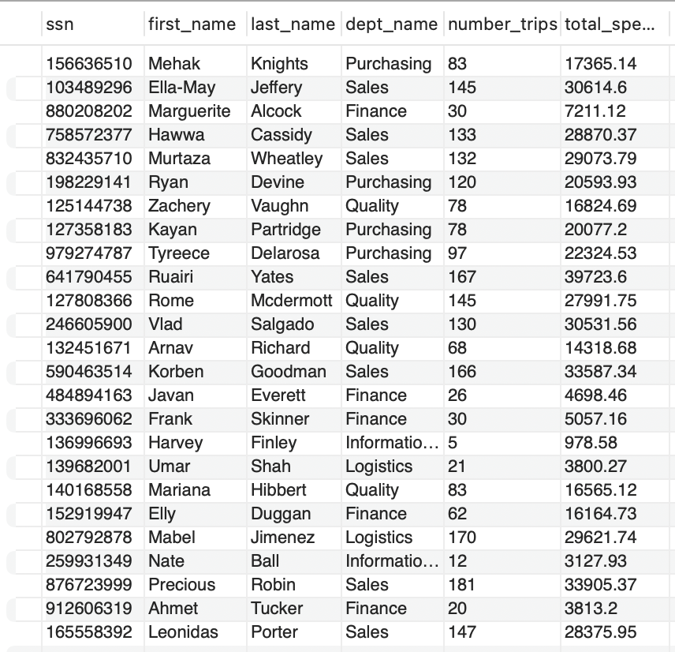

2. Create **four** SQL queries on your data warehouse that answer interesting important questions. At least two queries should be more than simple queries. For example, more complex queries could include Joins, a Group By element or a subquery or use some aggregate functions and summary calculations (see examples in the class lectures’ slides).

**#1 no. of trips for each reason in descending order**

SELECT reason_description, count(*) total_trips

FROM expense_dw_report e

JOIN trips t

ON t.employee=e.ssn

JOIN reason_codes r

ON t.reason_code=r.reason_code

GROUP BY t.reason_code

ORDER BY total_trips DESC;

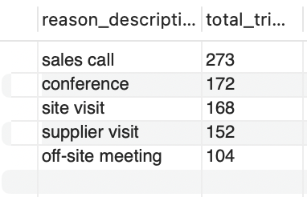

**#2 total amt spent by dept**

SELECT dept_name,sum(total_spent) total

FROM expense_dw_report

GROUP BY dept_name

ORDER BY total DESC;

**#3 total trips by dept**

SELECT dept_name,sum(number_trips) s

FROM expense_dw_report

GROUP BY dept_name;

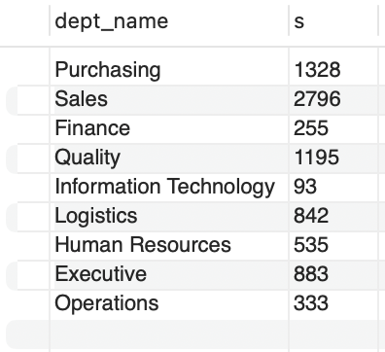

#**4 reimbursements per dept**

SELECT dept_name, ROUND(SUM(reimbursement_amount),2) reimbursement

FROM expense_dw_report exp

JOIN reimbursements reim

ON exp.ssn = reim.employee

GROUP BY dept_name

ORDER BY reimbursement DESC;

